# 📘 My English Hub

### Inglés A2 – Hablá con confianza en situaciones cotidianas

### 👋 Bienvenida

En este nivel vas a reforzar lo que ya sabés y expandir tu vocabulario y fluidez. Este material te va a acompañar para hablar con seguridad en tiendas, restaurantes, medios de transporte y situaciones comunes del día a día.

## 🛍️ Going shopping

### 🔹 Vocabulary and expressions

* How much is it?
* I’m looking for…
* Do you have this in another size?
* It’s too expensive / cheap / big / small.
* I’ll take it. / I’ll think about it.

### 🔸 Dialogue

👤 A: Hello, can I help you?  
👤 B: Yes, I’m looking for a black jacket.  
👤 A: What size are you?  
👤 B: Medium.  
👤 A: Try this one. It’s on sale.

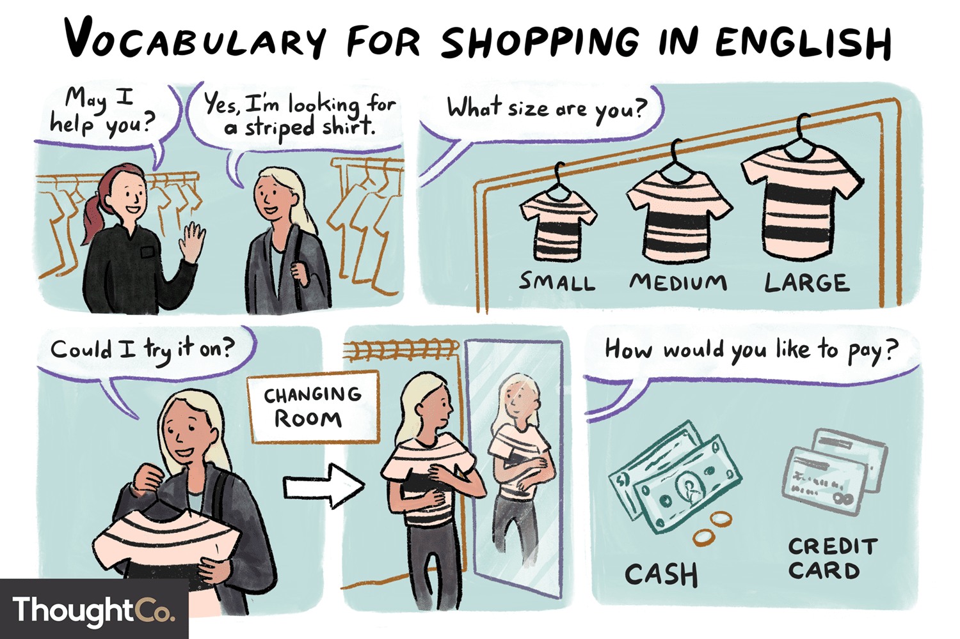

## 🍝 At the restaurant

### 🔹 Vocabulary and expressions

* I’d like… / Can I have…?
* What’s the special today?
* I’m allergic to…
* Could we see the menu, please?
* The bill, please.

### English vocabulary: Restaurant – Wat4English.com

### 🔸 Dialogue

👤 A: Hello, are you ready to order?  
👤 B: Yes, I’ll have the chicken and rice.  
👤 A: Anything to drink?  
👤 B: Hmm, just water, thank you.

## Transport – B1 English Vocabulary - Test-English🚆 Transport and directions

### 🔹 Vocabulary and expressions

* Where is the nearest station?
* I’m going to the airport.
* How much is a ticket to…?
* Take the bus / metro / train
* Get off at the second stop.

### Asking for and giving directions in English🔸 Dialogue

👤 A: Excuse me, how can I get to the museum?  
👤 B: Take bus number 10 and get off at main square.   
👤 A: Thank you very much!  
👤 B: You’re welcome!

## 🧩 Everyday expressions!

* I’m not sure. / I think so.
* Maybe later. / It depends.
* I’m in a hurry.
* Don’t worry. / Take your time.
* I’ll let you know. / Sounds good.

## 🎧 Interactive Exercises

➡️ Click on the links

1. [Shopping – Wordwall](https://wordwall.net/es/resource/3069270/shopping)
2. [At a restaurant](https://wordwall.net/es/resource/18804168/vocabulary/at-a-restaurant)
3. [Means of Transport](https://wordwall.net/es/resource/30813199/transport)

## ✅ Mini Test

1. “Can I have the ___, please?”  
   a) rice   
   b) raining  
   c) jacket
2. “Get ___ at the second stop.” (on a bus)  
   a) down  
   b) out  
   c) off
3. “How much ___ this?”  
   a) is   
   b) are  
   c) does

## 📲 ¿Querés seguir aprendiendo?

👉 Consultá por el próximo nivel B1  
👉 Escribinos por WhatsApp para recibir ayuda  
👉 ¡Sumate a My English Hub y seguí avanzando!